A Personal Side to History: The Story of St. Hilda’s By the Sea Anglican Church

By Terri Hopkinson
Museum Staff, Contributing Editors

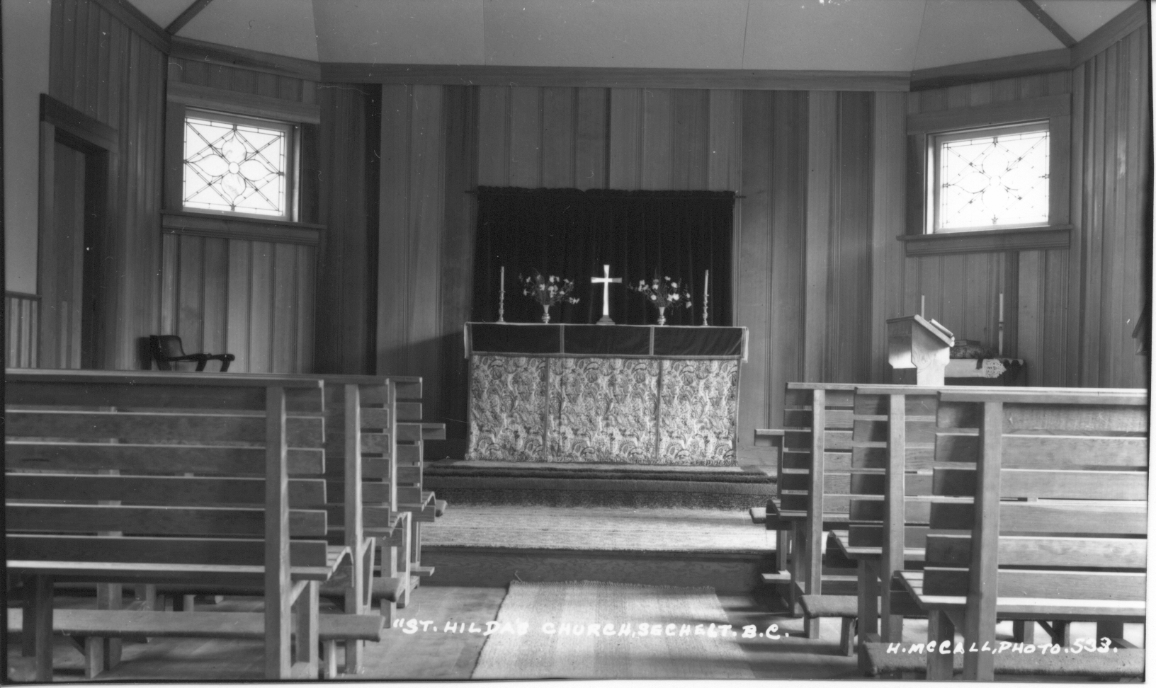

This summer I had the opportunity to spend fourteen weeks working for the Sunshine Coast Museum & Archives. It was a very special experience to work in a place dedicated to preserving the history of this small corner of the world that I have called home all my life. While working in the archives, every so often I would be stopped in my tracks by a photograph that brought back vivid memories. A photograph of Rockwood Lodge, for example, transported me back to the music lessons that I took there in the 1990s. A photo of Camp Elphinstone would remind me of the faded scar on my knee that I earned in an altercation with the camp’s “slip and slide”. These small revelations provided a personal significance to my work, and drew me deeper into the history of the region.
One day, I came across the above photograph taken in the 1930s. It’s a simple photo really, just an image of an empty chapel, and I almost skipped right past it until I read the caption. It simply said “An interior view of St. Hilda's Anglican Church, Sechelt.” The realization of where this photo was taken brought such a flood of memories that it made me dizzy. You see, this is a photo of my church taken when it first opened in 1936.
Studying the photograph, I recognized nothing in the picture. The pews I sat on were much more comfortable than these wooden benches appear; the altar where I took communion is conspicuously absent. I could see from other exterior photographs that the hall attached to the church wasn’t added on until later. After some further research I discovered that there was a good reason I recognized nothing - the church was entirely rebuilt in 1985. Still, in the emotional sense and in every way that matters, this is a photograph that holds a deep personal significance.
While St. Hilda’s history begins with services in an old Porpoise Bay schoolhouse in 1916, my history with the church does not begin until 1990 when my parents were married there. In 1982, the school district placed a small classroom building on the Church’s lot – that’s where I later went to pre-school. The basement added in the 1985 rebuild was where my Sunday School lessons took place. My high school days at Chatelech led me to walk nearly every day through the easement granted in 1976 at the back of the church grounds. My Girl Guide troop met in the hall that was added onto the church in 1949. I remember the day they began painting the Labyrinth in 2002.
While I have not set foot in St. Hilda’s for almost ten years, I could still easily go on for ten pages to describe my every memory of this place at length. This flood of images and stories comes from looking at one photograph. Without that reminder, these memories would still be locked away like old toys; I relished the opportunity to dust them off and play with them again.
To most people, this is just an old photograph of a church, but to me … well, I think you realize by now what it is to me. This photograph represents an entry point into a vivid collection of memories- it invites me to explore the changes in my community and myself. That is the power of history. Beyond the stories preserved in the archives, the Sunshine Coast Museum holds billions of memories just waiting to be discovered. And all it takes is one photograph…

